**Frequently bought together (FBT) - woocommerce plugin**

**Boost sales & enhance customer experience with smart product bundles**

The Frequently Bought Together (FBT) plugin for WooCommerce is a powerful marketing tool designed to increase average order value (AOV) by encouraging customers to purchase complementary products in a single click. This plugin intelligently displays related products that are often purchased together, making it easier for shoppers to discover and add bundled items to their cart.

**🔹 Key features:**

**✅ Smart product suggestions** – Display frequently bought-together products on single product pages.

**✅ Variable product support** – Works seamlessly with simple, variable, and custom product types.

**✅ Customizable design** – Match the plugin’s appearance with your store’s branding (button colors, text, and styling).

**✅ Real-time price calculation** – Shows the total price of selected products dynamically.

**✅ One-click add to cart** – Customers can add all selected products to their cart instantly.

**✅ Variation selection modal** – Allows users to choose product variations (size, color, etc.) before adding to cart.

**✅ Admin controls** – Easily manage which products appear together via a simple meta box.

**✅ Shortcode support** – Display the FBT section anywhere using [frequently_bought_together].

**✅ Toast notifications** – Provides visual feedback when products are added to the cart.

**🔹 How it works**

1. **Admin configuration:**

* Set default products to be suggested together.
* Customize button colors, text, and section title.
* Choose whether checkboxes are selected by default.
* Enable/disable variation price display.

1. **Frontend experience:**

* Customers see a "Frequently Bought Together" section below the add-to-cart button.
* They can select/deselect products and choose variations (if applicable).
* The total price updates in real-time based on selections.
* Clicking "Add All to Cart" adds all checked items in one go.

1. **Marketing benefits:**

* Increases AOV by encouraging bundled purchases.
* Reduces cart abandonment with a seamless checkout experience.
* Improves product discovery by showcasing relevant items.

**🔹 Why choose this plugin?**

✔ Lightweight & fast – No bloated code; optimized for performance.

✔ User-friendly – Simple setup with intuitive controls.

✔ Highly customizable – Match your store’s branding effortlessly.

✔ Mobile-friendly – Works perfectly on all devices.

✔ SEO & conversion optimized – Helps improve engagement and sales.

**🔹 Future Enhancements (Coming Soon!)**

* Discounts on bundles – Apply percentage or fixed discounts when customers buy multiple products together.
* Quantity selection – Allow customers to adjust the quantities for each product in the bundle.
* Default products via comma-separated IDs – Predefine global product bundles in the settings.
* Smart recommendations – AI-driven suggestions based on customer behavior.
* Analytics dashboard – Track which bundles perform best.

**🔹 Installation & setup**

1. Upload the plugin ZIP file via wordpress Admin → Plugins → Add New.
2. Activate the plugin.
3. Configure settings under woocommerce → FBT Settings.
4. Assign related products in the "Frequently Bought Together" meta box on product pages.

**🎯 Boost your woocommerce store’s revenue today!**

By integrating the Frequently Bought Together plugin, you’ll enhance the shopping experience while driving higher sales through strategic product bundling. Download now and start increasing your average order value effortlessly!

* **Plugin URL:** [https://dev.bioicawtech.com/](https://dev.bioicawtech.com/ )
* **Support:** Contact us for customization or assistance.
* **Email:** saadhassan909@gmail.com

**🎯 Visual Representation of plugin:**

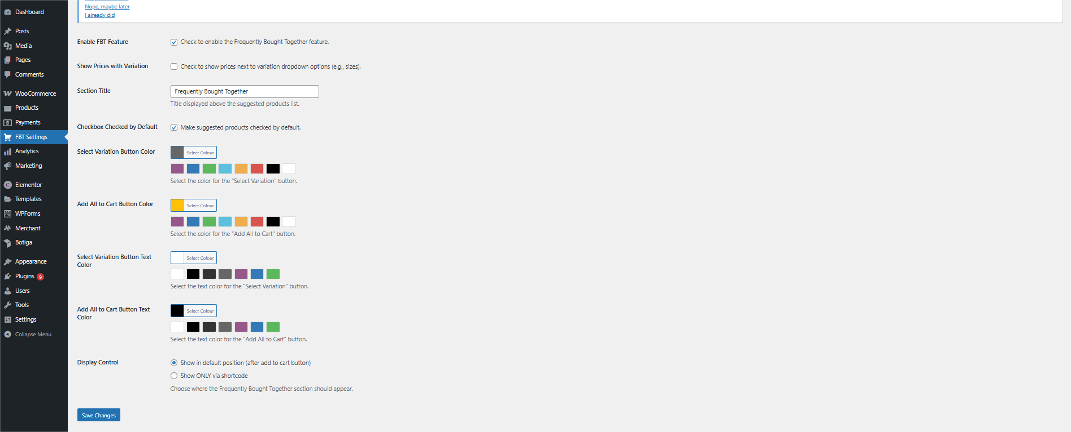

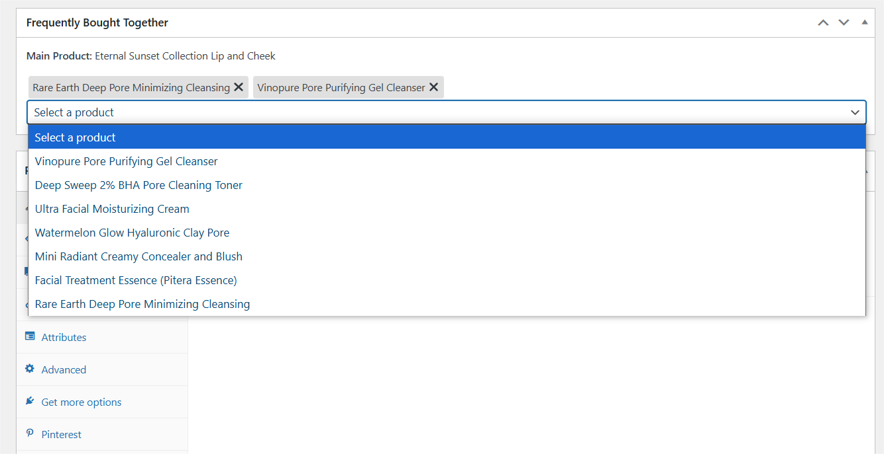**On woocommerce product page:**

**On frontend:**

